Bug Report – Standard Format

BUG-01

Title

[Registration] – UI not matching Figma– When user opens registration page Environment
QA | Build 1.0 | Chrome | User Precondition:
- User is on homepage.
- Registration page is accessible.

Steps to Reproduce:
• Open homepage.
• Click Login.
• Click Register.

Actual Result: Registration page layout does not match approved Figma design.

Expected Result: UI should match approved Figma design.

Severity : High
Priority: High
Severity: High
Priority: P0

Attachment: 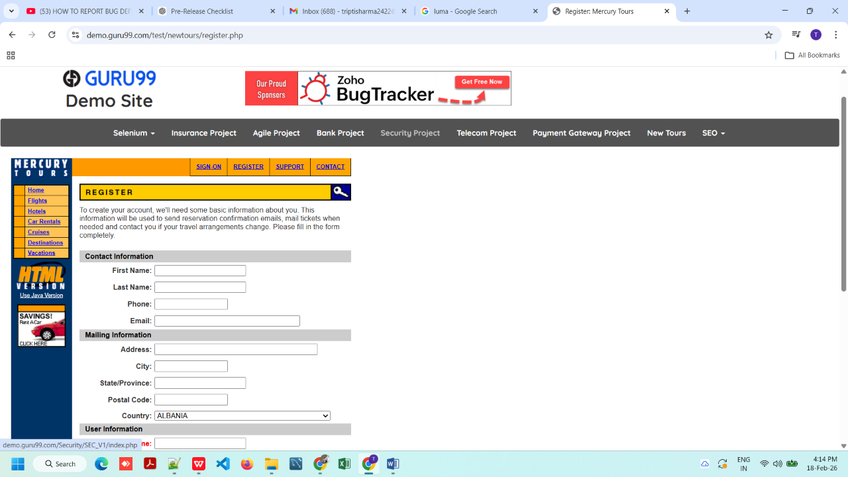
Fig.1
BUG-02

Title

[Registration] – Invalid email accepted – When user enters wrong email format
Environment
QA | Build 1.0 | Chrome | User
Precondition:
1. Open the home page.
2. URL:https://demo.guru99.com/test/newtours/index.php 3.User have tapped on Register Now button.
Steps to Reproduce:
• Enter invalid email (abc@)
• Click Submit
Actual Result: System accepts invalid email.

Expected Result:
Validation error should appear
Severity : High
Priority: High
Severity: High
Priority: P0
Attachment: 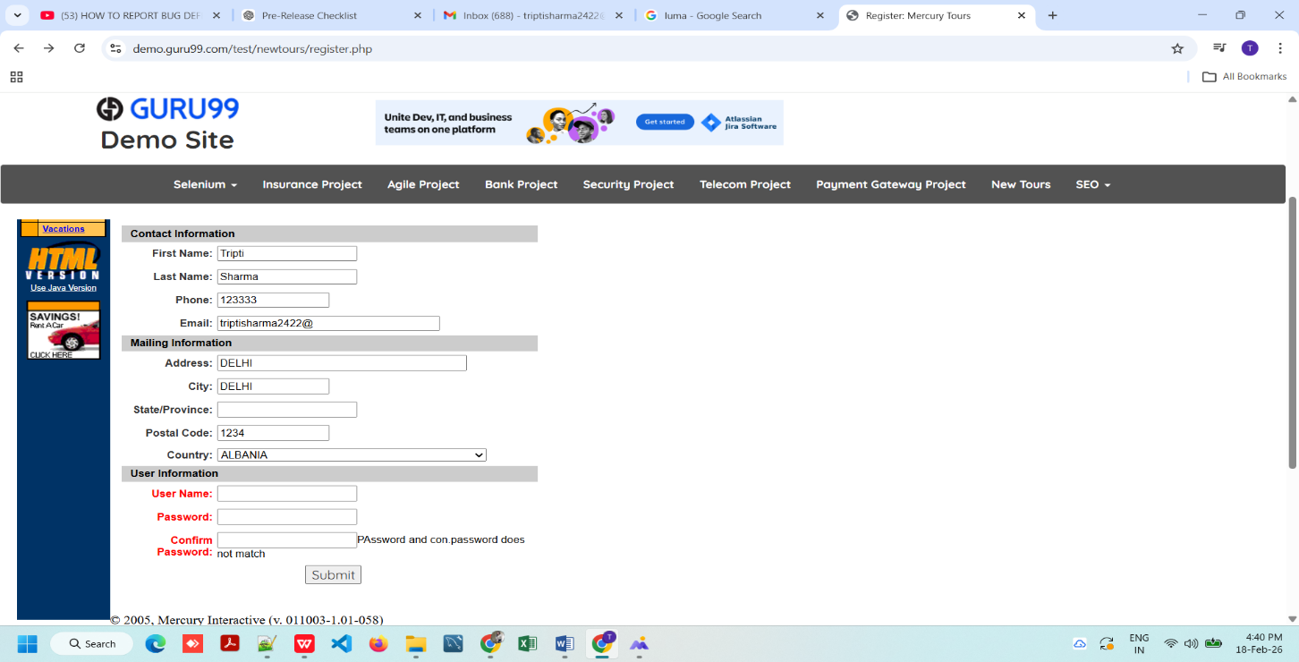
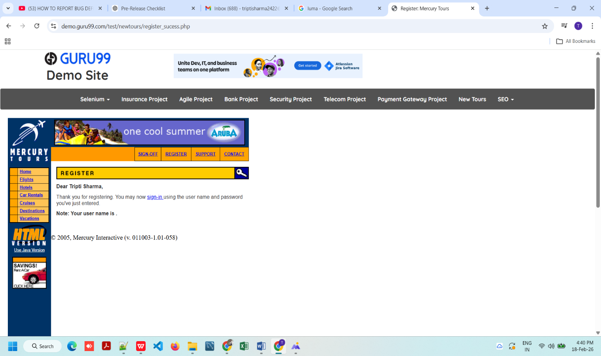

BUG-03

Title

[Registration] – Form submits without mandatory fields – When user clicks submit without data. Environment
QA | Build 1.0 | Chrome | User Precondition:
1. Open the homepage.
2. URL:https://demo.guru99.com/test/newtours/index.php
3. User have tapped on Register Now button.
4. Registration page loaded.

Steps to Reproduce:
• Leave all fields blank
• Click Submit
Actual Result: Form submitted successfully.

Expected Result: Validation errors for all mandatory fields.
Severity : Critical
Priority: High
Severity: High
Priority: P0
Attachment:
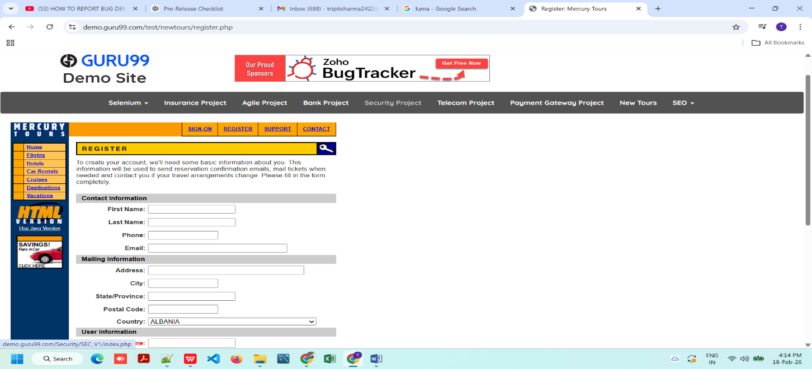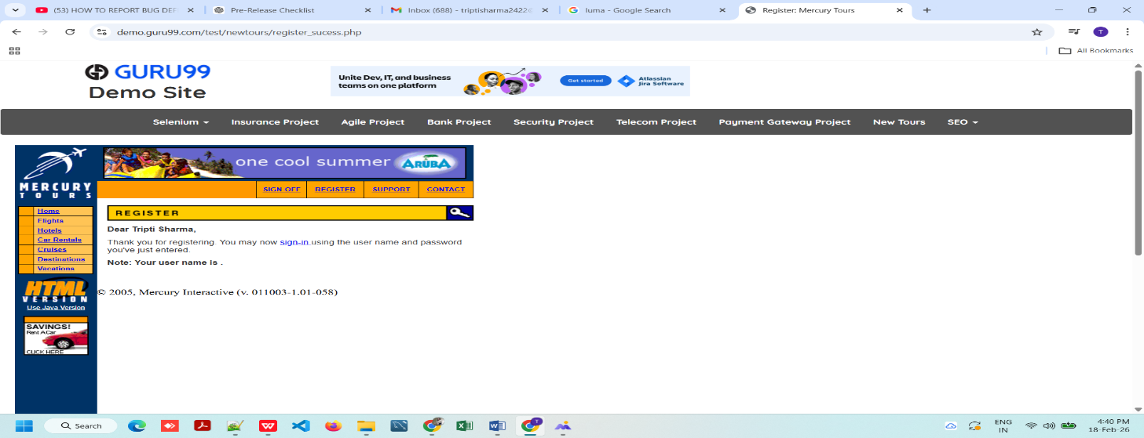

BUG-04

Title

[Registration] – Phone field accepts alphabets – When user enters letters. Environment
QA | Build 1.0 | Chrome | User Precondition:
1. Open the homepage.
2. URL:https://demo.guru99.com/test/newtours/index.php
3. User have tapped on Register Now button.
4. Enter "abcdef" in phone field.

Steps to Reproduce:
• Enter "abcdef" in phone field.
• Tap on submit button.
Actual Result: Phone field accepts alphabets

Expected Result: Only numeric values allowed.
Severity : High
Priority: High
Severity: High
Priority: P0
Attachment: 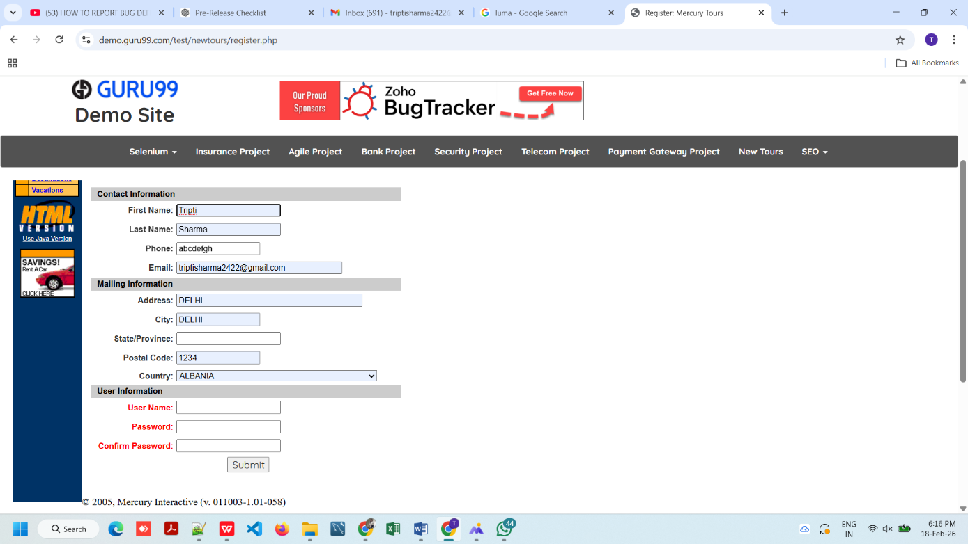
Fig.4

BUG-05

Title :

[Registration] – Required fields not marked (*) – On registration page load Environment :

QA | Build 1.0 | Chrome | User Precondition:
1. Open the homepage.
2. URL:https://demo.guru99.com/test/newtours/index.php
3. User have tapped on Register Now button.
4. Hit the submit button without fill the any details.

Steps to Reproduce:
• Leave all fields blank
• Hit the submit button.
Actual Result: Mandatory fields not marked with asterisk.
Expected Result: All required fields should display (*).
Severity: Medium
Priority: Medium
Priority: P1
Attachment:
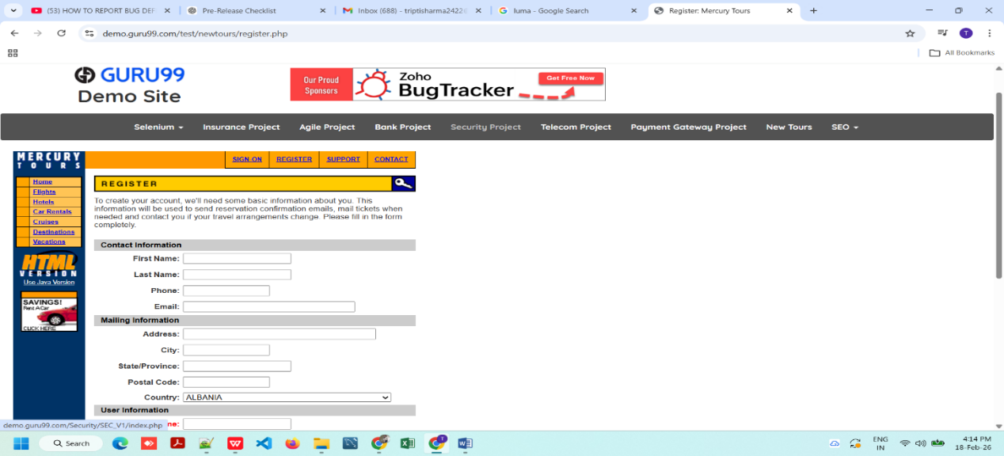
(Mandatory fields not marked with asterisk.)

BUG-06

Title:

[Registration] – Phone accepts less than 10 digits – When user enters 6 digit number Environment:

QA | Build 1.0 | Chrome | User Precondition:
1. Open the homepage.
2. URL:https://demo.guru99.com/test/newtours/index.php
3. User have tapped on Register Now button.
4. Enter: 123456 and click the submit button.

Steps to Reproduce:
• Phone accepts less than 10 digits: 123333
• Hit the submit button.
Actual Result: System accepts 6 digit phone number.
Expected Result: Phone number must be exactly 10 digits.
Severity: High
Priority: High
Priority: P0
Attachment:
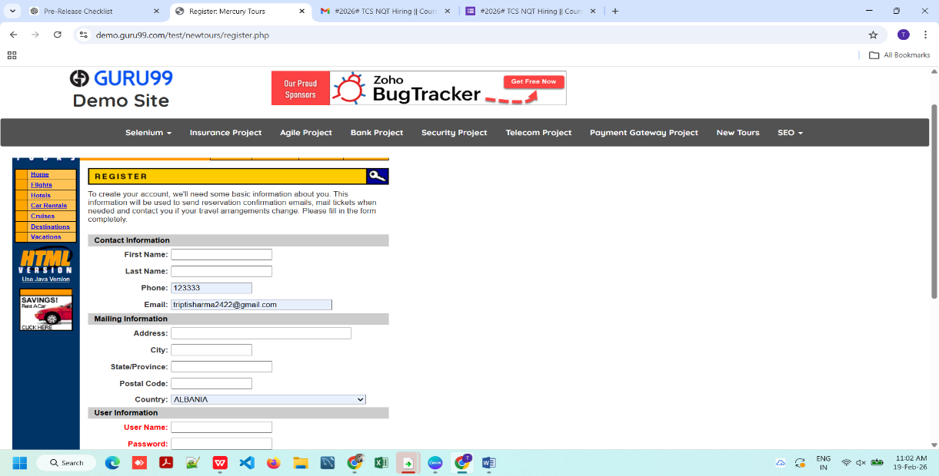
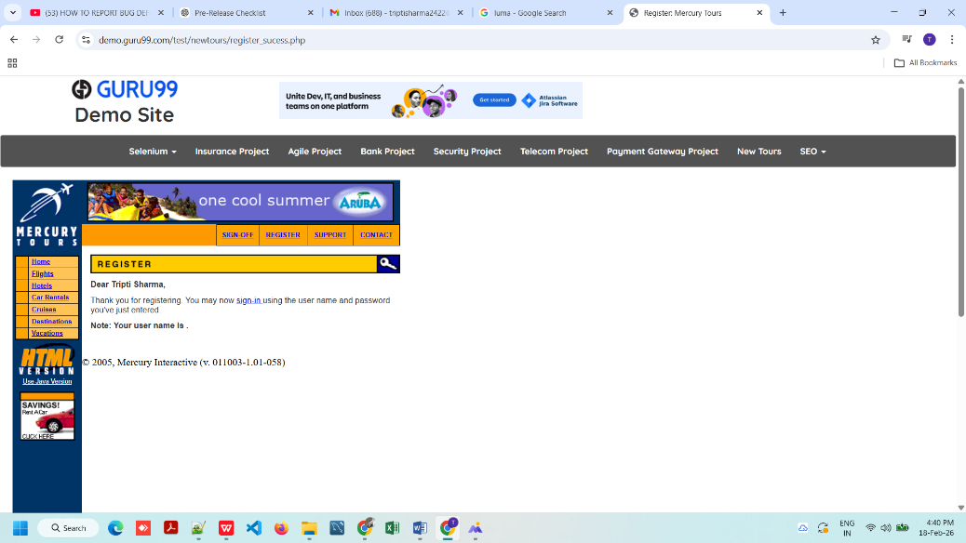

BUG-07

Title:

[Hotels] – Under Construction page displayed – When user clicks Hotels link. Environment:

QA | Build 1.0 | Chrome | User Precondition:
1. Open the homepage.
2. URL:https://demo.guru99.com/test/newtours/index.php
3. User have tapped on Register Now button.
4. click on hotels link.

Steps to Reproduce:
• Click on “Hotels” from left menu.
• Hit the submit button.
Actual Result: Page shows “Under Construction”.
Expected Result: Hotels booking page should open.
Severity: High
Priority: High
Priority: P0
Attachment:
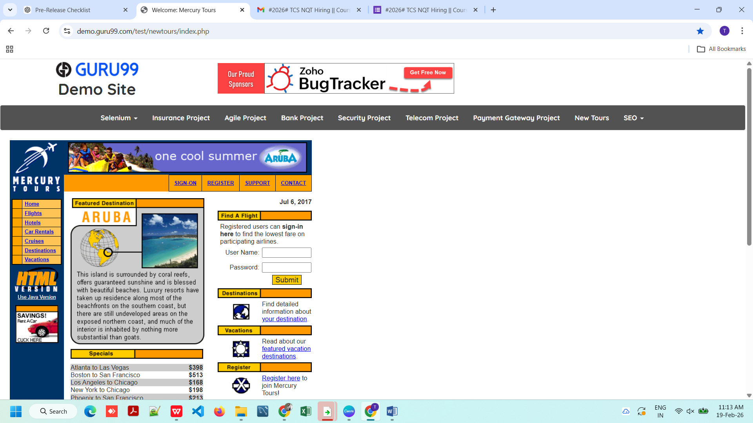
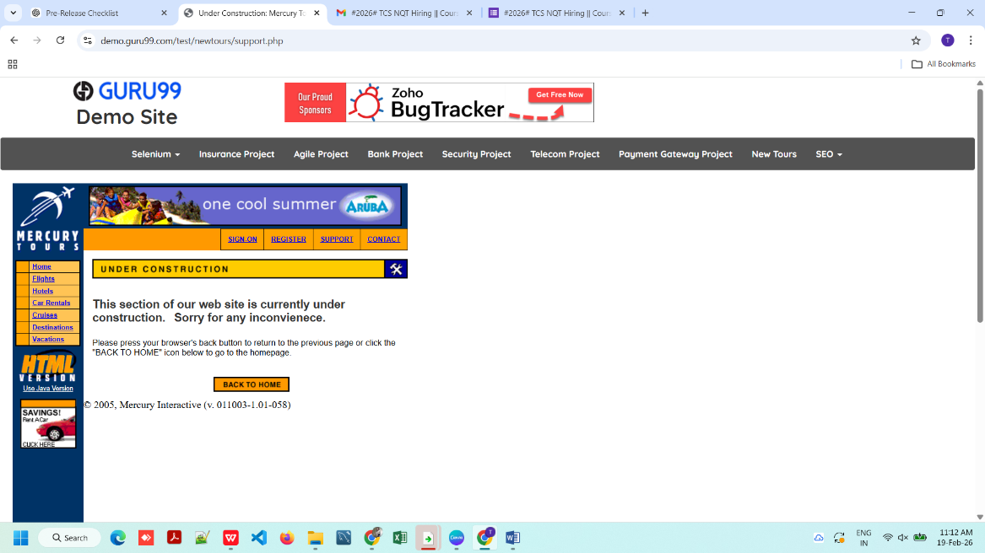

BUG-08

Title:

[Car Rentals] – Under Construction page displayed – When user clicks Car Rentals link. Environment:

QA | Build 1.0 | Chrome | User Precondition:
1. Open the homepage.
2. URL:https://demo.guru99.com/test/newtours/index.php
3. User have tapped on Register Now button.
4. Click on Car Rentals link.

Steps to Reproduce:
• Click on “Car Rentals” from left menu.
• Hit the submit button.
Actual Result: Page shows “Under Construction”.
Expected Result: “Car Rentals” booking page should open.
Severity: High
Priority: High
Priority: P0
Attachment:
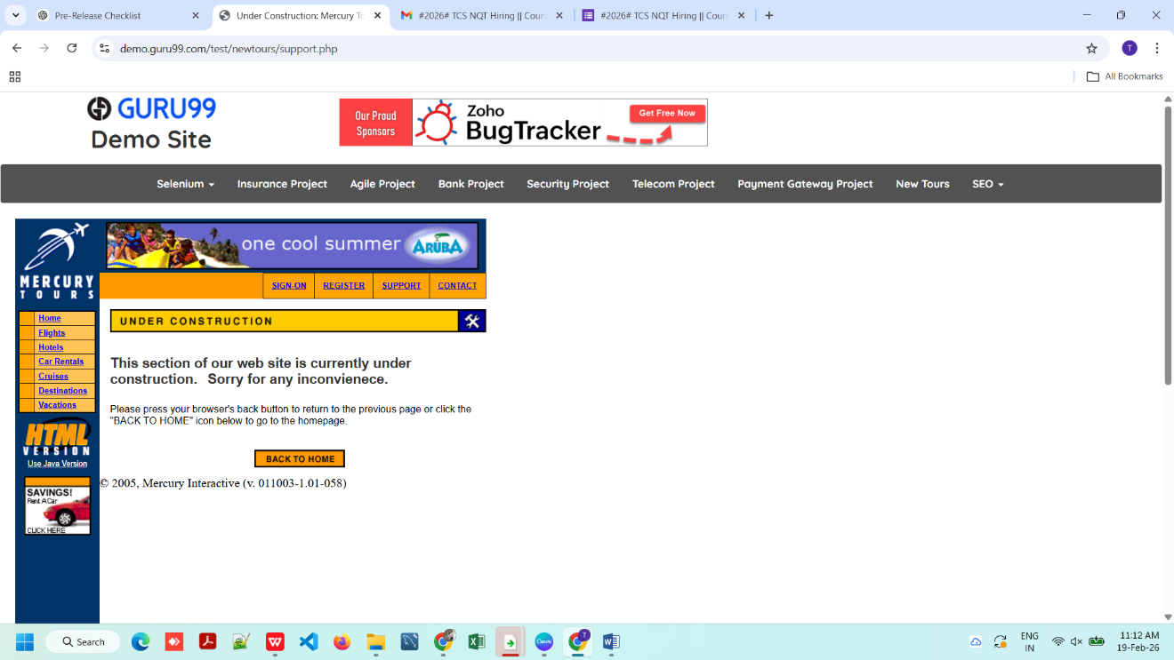

BUG-09

Title:

[Cruises/Destinations/Vacations] – Links not working – When user clicks menu links. Environment:

QA | Build 1.0 | Chrome | User Precondition:
1. Open the homepage.
2. URL:https://demo.guru99.com/test/newtours/index.php
3. User have tapped on Register Now button.
4. Click on [Cruises/Destinations/Vacations] link.

Steps to Reproduce:
• Click on “[Cruises/Destinations/Vacations]” from left menu.
• Hit the submit button.
Actual Result: Page shows “Under Construction”.
Expected Result: “[Cruises/Destinations/Vacations]” booking page should open.
Severity: High
Priority: High
Priority: P0
Attachment:


BUG-10

Title:

[Insurance] – Fields misaligned – On Sign Up page. Environment:

QA | Build 1.0 | Chrome | User Precondition:
1. Open the homepage.
2. URL:https://demo.guru99.com/test/newtours/index.php
3. User have tapped on Register Now button.
4. Click on Insurance project button.

Steps to Reproduce:
1. Click on Insurance Project.
2. Navigate to Sign Up page.
3. Observe alignment of Title, (First Name, Surname, Phone, DOB fields).
4. Hit the submit button.
Actual Result: Input fields not properly aligned.
Expected Result: Proper alignment and spacing.

Severity: Medium
Priority: Medium
Priority: P1
Attachment:
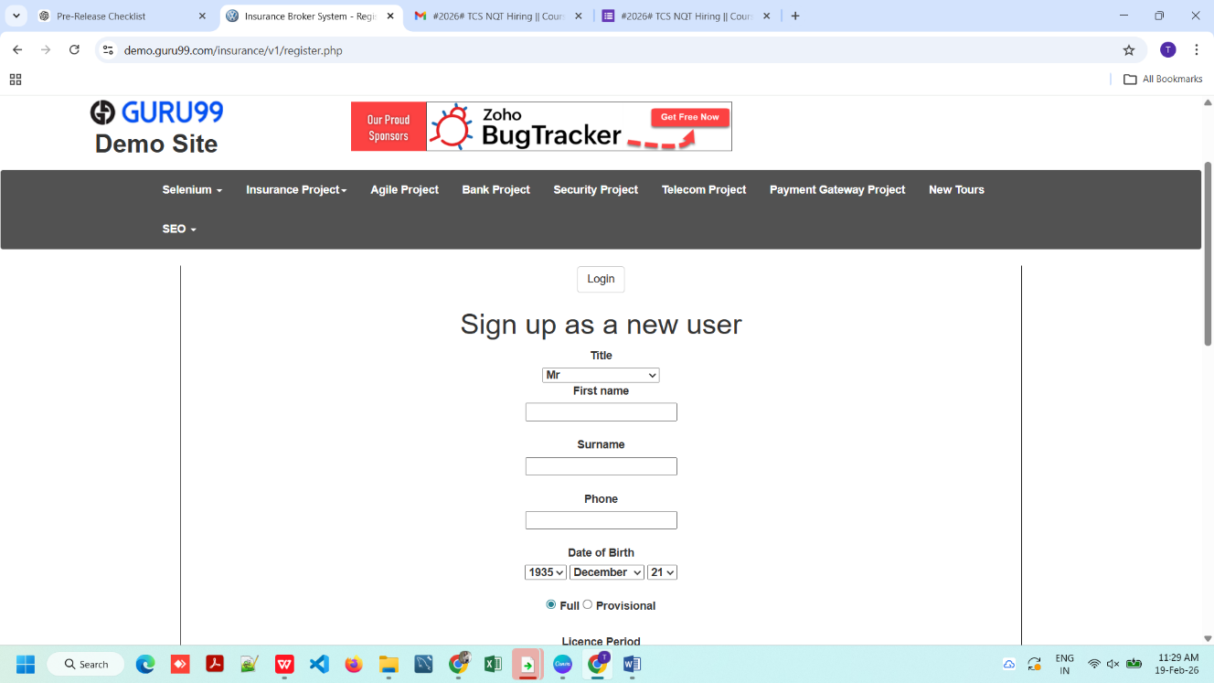

BUG-11

Title:

[Insurance Register] – No validation for blank fields – When user submits empty form. Environment:

QA | Build 1.0 | Chrome | User Precondition:
1. Open the homepage.
2. URL:https://demo.guru99.com/test/newtours/index.php
3. User have tapped on Register Now button.
4. Click on Insurance project button.

Steps to Reproduce:
1. Open the homepage
2. URL:https://demo.guru99.com/test/newtours/index.php 3. Click on Insurance project button.
4. Click on register link.
5. Enter the invalid data (number and password.)

Actual Result: No error message displayed.
Expected Result: Validation error should appear.

Severity: Critical
Priority: Medium
Priority: P1
Attachment:
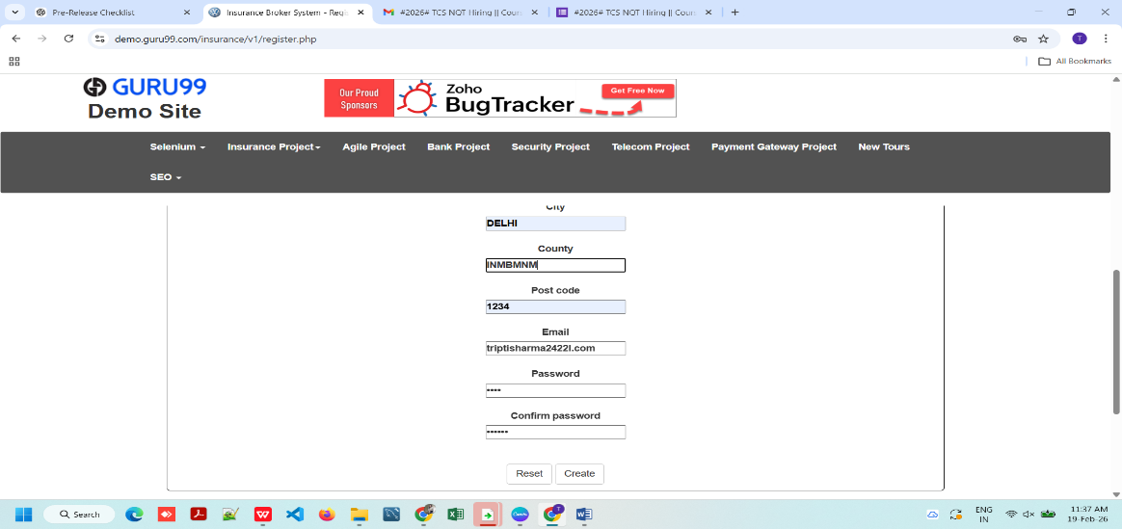
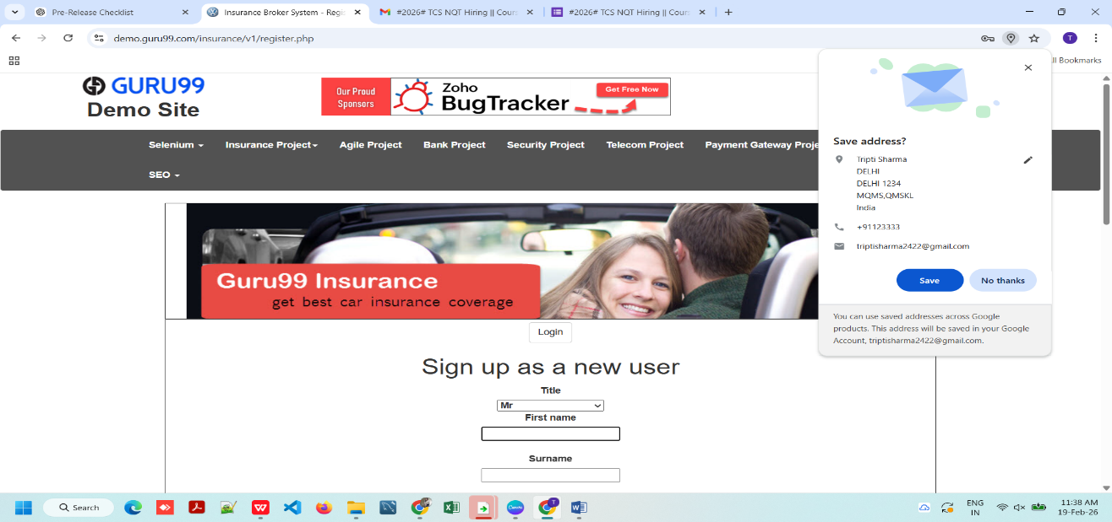

BUG-12

Title:

[Support] – Under Construction page displayed – When user clicks Support link. Environment:

QA | Build 1.0 | Chrome | User Precondition:
1. Open the homepage.
2. URL:https://demo.guru99.com/test/newtours/index.php
3. User have tapped on Register Now button.
4. Click on Support link.

Steps to Reproduce:
Click on “Support link” from left menu.
• Hit the submit button.
Actual Result: Support page shows Under Construction message.
Expected Result: Support page should open properly.
Severity: Medium
Priority: Medium
Priority: P1
Attachment:


